Software Engineering Tools Lab Assignment No-3

(Module 3- Study of Project Management Tool (Jira))

**2020BTECS00023**

**Sumit Narake**

**T-5**

1. Create a project (give name of your project) in Jira, use template as Scrum and add your team members into this project.

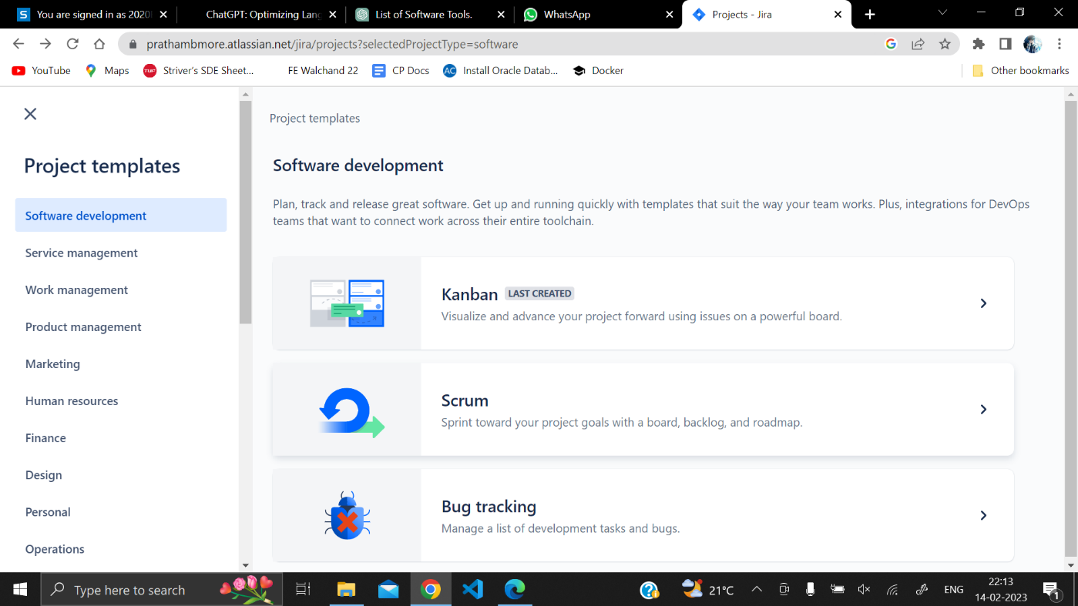

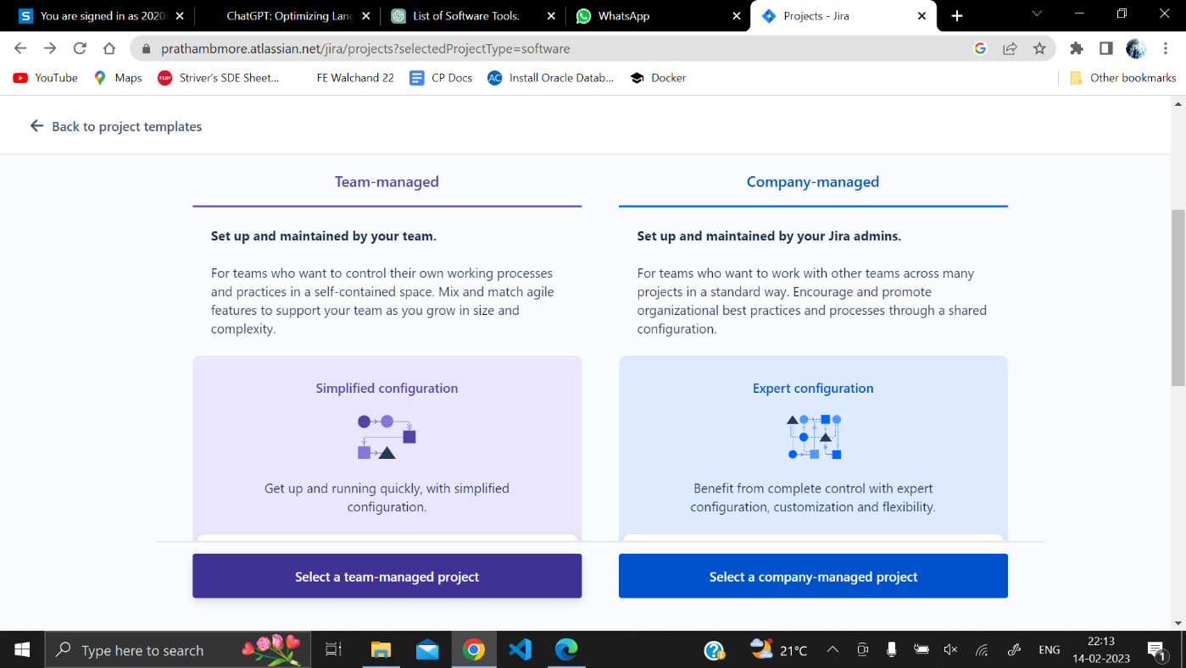

1. Create an Epic into above project (main requirement of your project, e.g Creating a web application for student result generation).

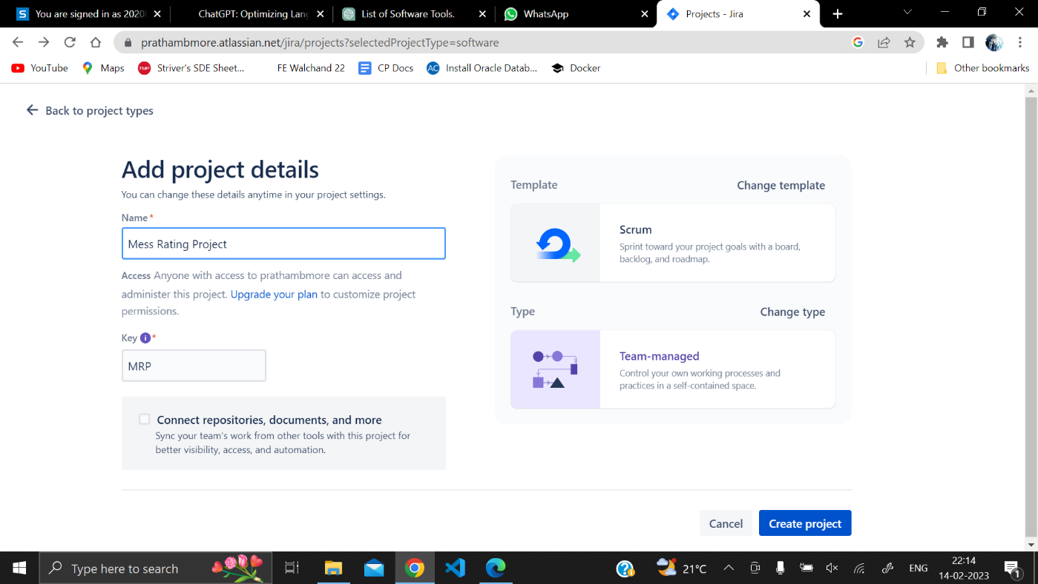

1. Create at least 5 user stories with respect to above epic for your project.

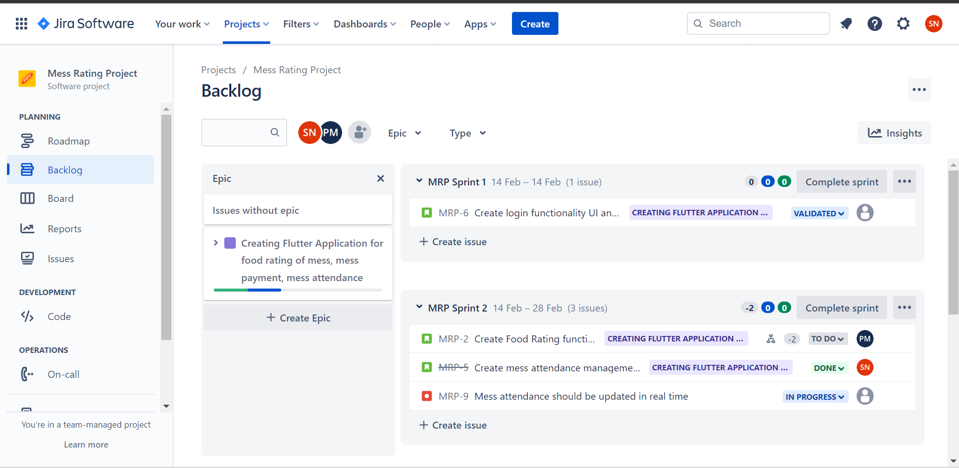

1. Create at least 2 subtasks for every user story. Assign user stories to your team members.

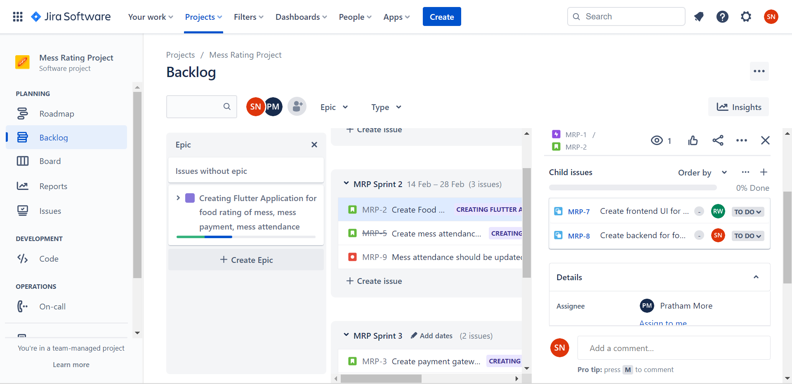

1. Create sprints for every use stories and prioritize them according to your tasks. Assign time period for every user story.

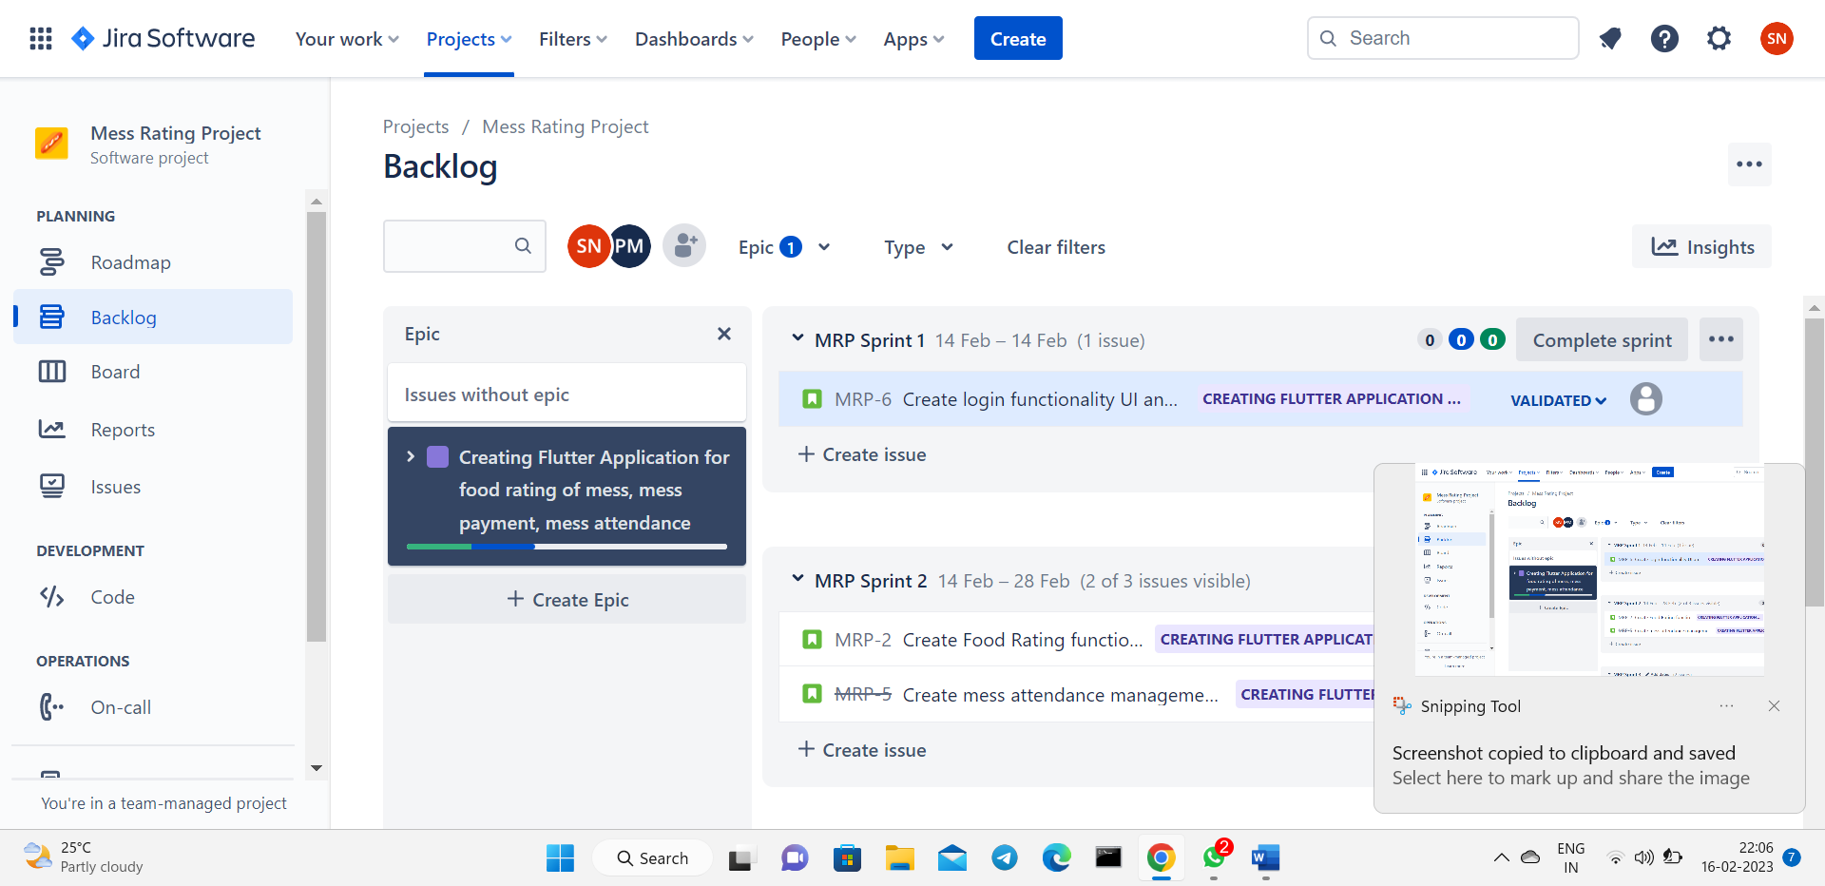

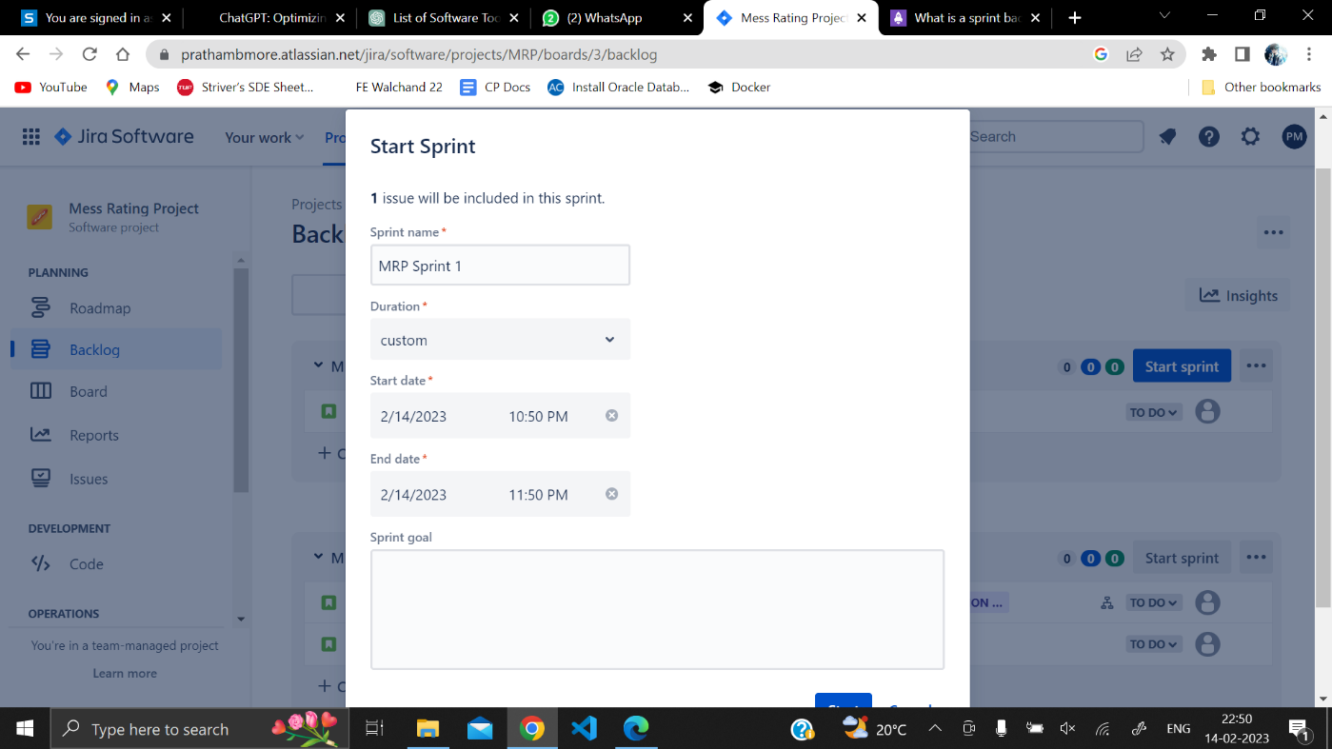

1. Update the status of some user stories as To Do, In Progress or Completed according to sprints (add appropriate comments).

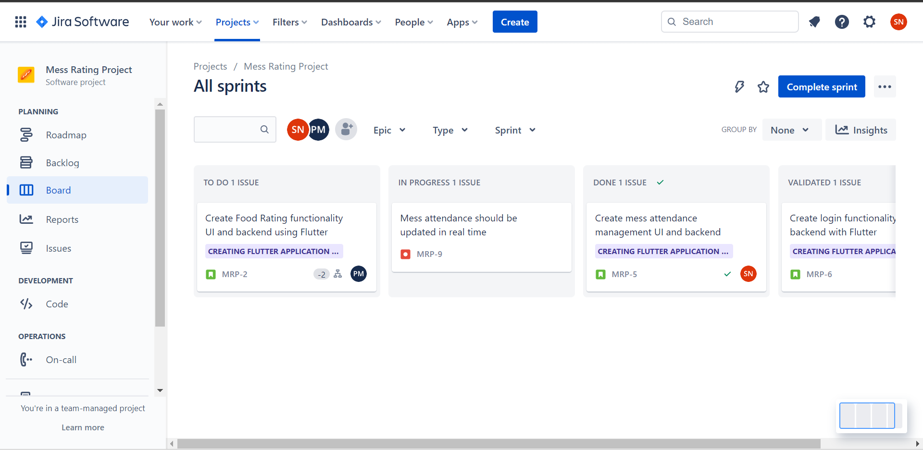

1. Create a bug/issue for respective user story and epic and assign to respective member.

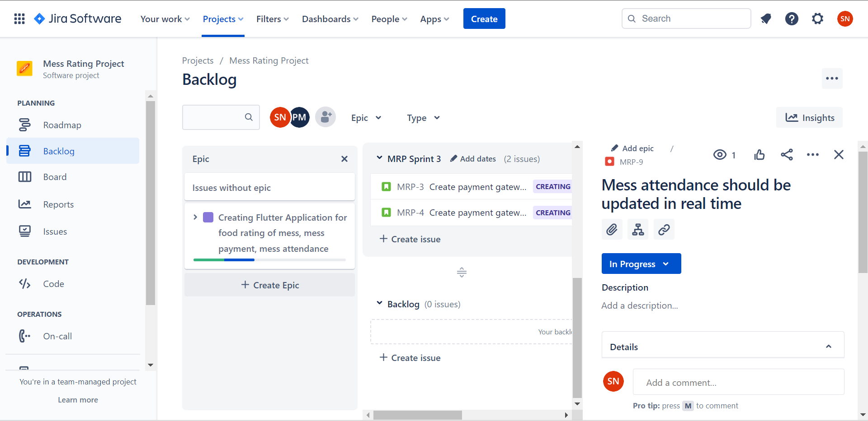

1. Display reports (Burnup chart, Burndown chart) w.r.t your created project.

